Chapter 17, Problem 32.

Find i(t) in the circuit of Fig. 17.68 given that

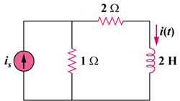

Figure 17.68
For Prob. 17.32.

